Basic Informations about Sikkim. Collected by Thorsten Schütze, 04.2002

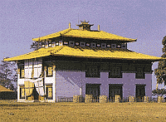
http://india-tourism.de/english/east/sikkim.html

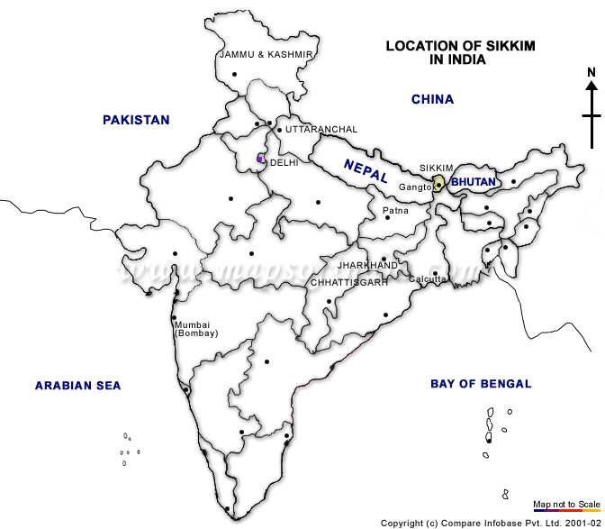

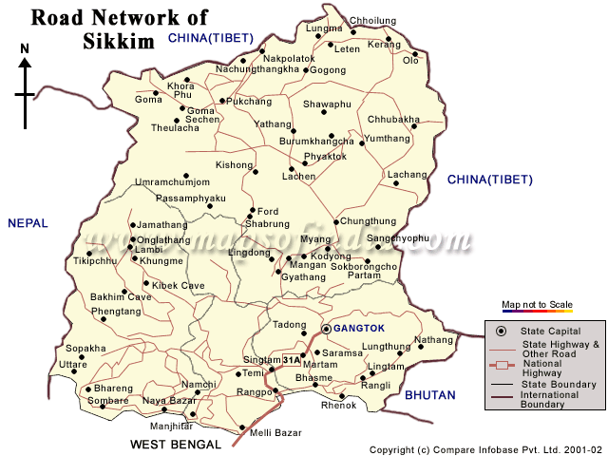
Area : 7229 sq. Kms.
Population: Sikkim- around three lakh and Gangtok- around 40 thousands.
Literacy rate: 56.94%
Main Language: Napalese
Near by cities: Bagdogra- 124 Kms, Siligurhi- 114 kms, Kalempong- 75 Kms, Jalpaigurhi-
125 kms, Calcutta- 724 Kms
Sikkim is the 22nd state of India came into existence with effect from 26th April, 1975. Sikkim state being a part of inner mountain ranges of Himalayas, is hilly having varied elevation ranging from 300 to 8540 meters. But the habitable areas are only up to the altitude of 2100 mtrs. Constituting only 20% of the total area of the state. Sikkim has been divided into four districts and each district has further been bifurcated into two sub-divisions for administrative purpose.
The highest portion of sikkim lies in its north west direction. A large number of mountains having altitudes of about seven thousand meters stands here with - Kanchenjunga (8598 m.), The third highest peak in the world. The high serrated, snow capped spurs and peaks of Kanchenjunga look attractive consisting of Kumbha Karna (7711 m.), Pendem (6706 m.), Narsingh (5825 m.), Kabru Dome (6545 m.), etc. A number of glaciers descends from eastern slopes of Kanchenjunga into Sikkim where snow clad line is found above 5300 mtrs. The biggest of them is Zemu, from whose snout above Lachen monastery rises the river Teesta.
Teesta is the main river and its main tributaries are Zemu, Lachung, Rangyong, Dikchu, Rongli, Rangpo and Rangit which form the main channel of drainage from the north to the south. It boasts of the great mount Kanchendzonga as its crown. Ethically Sikkim has mainly three groups of people viz. Nepalis, Bhutias, Lepchas. The local language is Nepali. English is the official language. This jewel- like mountain state of ethereal beauty with an area of 7299 sq. kms , nestles in the heart of Himalayas. Cradled in the manifold splendors of nature deep within the snow clad Himalayas is Sikkim's capital Gangtok. Wrapped in mists and clouds, a garden state with an incredible variety of rhododendrons & a host of other flowers.
Geomorphology
Sikkim encompasses the lesser Himalaya, Central Himalaya, and the Tethys Himalaya. It is essentially a mountainous state without flate piece of land of any extent any where. The mountains rise in elevation northward. The northern portion of the state is deeply cut into steep escarpments, and except in the Lachen and Lachung valleys, is not populated. Southern Sikkim is lower, more open, and fairly well cultivated. This configuration of the State is partly due to the direction of the main drainage which is southern.
The physical configuration of Sikkim is also partly due to geological struture. Major portion od state is covered by Precambrian rock and is much younger in age. The Northern, Eastern and Western portion of the state are constituted of hard massive gneissose rocks capable of resisting denudation. The central and southern portion is formed of comparatively soft, thin, slaty and half-schistore rocks which denudes very easily. The trend of the mountain system is in a general east-west direction. However, chief ridges run in a more or less north south direction.
The Rangeet and the Tista which form the main channels of drainage, run nearly north-south. The valleys cut by these rivers and their chief feeders are very deep. The valleys are rather open towards the top, but usually attain a steep gorge like structure as we approach the bed of the rivers. There are 180 perennial lakes of different altutudes. Many hot water springs i.e. Phur-Cha, Ralang Sachu, Yumthang, Momay are also found in the state. The Perpetual snow line in Sikkim may be approx. at 16,000 ft. Demographic Features :- Sikkim is a multi-ethnic state. Broadly, the population can be divided into tribal and non-tribal groups. Lepchas, Bhutias, Sherpas are categorized as Scheduled Tribes.
The Lepchas are the original inhabitants of the state. Compared to other ethnic groups, the Lepchas still maintain many of their traditional ways. The Bhutias comprise, the sikkimese Bhutia and Bhutia from Bhutan and Tibet. The Sherpas are a marginal ethnic group in the state. over 70% population consist of Nepalese. They are dominant ethnic group in the state.
The people from the plain, mostly involed in trade and services represent a marginal group. As per the 1991 census of India, the total population of the state is 406457, whereas in 1981 it was 3,16,385 only. Dicennial growth has come down, as in 1971-81 it was 50.77% where as for 1981-91 it is 28.47% only. The overall density of population in the state is 57 per sq. Km. East district is the most populated where as North's density only 7, is least populated. Sex ratio ( females per thousand male) in 1981 was 835, where as it has improved and now is 878. There are only eight urban towns and urban population is 9.10% of total population. Schedule caste and schedule tribe population is 5.93 % and 22.36% respectively, North district is a tribal district and it has about 55.38% tribal population. Literacy rate is 56.94% (19th position), higher than the all India average literacy tare of 52.11%.
Location
Sikkim is a very small hilly state in the Eastern Himalayas, extending approximately 114 Kms from north to south and 64Kms from east to west, surrounded by vast stretches of Tibetan Plateau in the North, Chumbi Valley of Tibet and the kingdom of Bhutan in the east, Darjeeling district of West Bengal in the south and the kingdom in Nepal in the west . The state being a part of inner ranges of the mountains of Himalayaa has no open valley and no plains but caried elevations ranging from 300 to 8583 mtrs above means sea level consisting of lower hill, middle and higher hills, alpine zones and snow bound land, the highest elevation 8583 mtrs. being the top of the Mt. Kangchendzonga itself.
Climate
The climate of the state has been roughly divided into the tropical, temperature and alphine zones. For most of the period in a a year, the climate is cold and humid as rainfall occurs in each month. The area experience a heavy rainfall due to its proximity to the Bay of Bengal. The rainfall in north district is comparatively less than of the other districts. The general trend of decrease in temperature with increase in altitude holds good every where. Pre-monsoon rain occurs in April-May and monsoon (south-west) operates normally from the month of May and continues up to early October.
Temperature
The mean temperature in the lower altitudinal zone, it varies from 1.5 degree centigrade to 9.5 degree centigrade. Temperature varies with altitude and slope. The maximum temperature is recorded usually during July and August, and minimum during December & January. Fog is a common feature in the entire state from May to September. Biting cold is experienced at high altitude places in the winter months and snowfall is also not uncommon during this period.
Rainfall
An examination of availble rainfall date shows that the mean annual rainfall is minimum at Thangu (82 mm.) and maximum at Gangtok (3494 mm.) . An isohyatal analysis of these data reveals that there are two maximum rainfall areas (i) South-East quadrant, including including Mangan, Singhik, Dikchu, Gangtok, Rongli etc. (ii) South-West corner including Hilley . In between these two regions, there is a low rainfall region e.g. Namchi. Rainfall in this area is about half of that in the former areas. There is an area in the North-West Sikkim which gets very little rainfall (even less than 4.9 mm.). This area is having mainly snow -covered mountains. Rainfall is heavy and well distributed during the months from May to early October. July is the wettest month in most of the places. The intensity of rainfall during South-West monsoon season decreases from south to North, while the ditribution of winter rainfall is in the opposite order. The highest annual rainfall for the individual station may exceed 5000 mm. and average number of rainy days ( days with rain of 2.5 mm. or more) ranges from 100 at Thangu to 184 at Gangtok.
http://www.1uptravel.com/states/sikkim/

Temperature and Rainfall in India
T= Temperature in C
R= Rainfall average
Place Jan Feb Mar Apr May Jun Jul Aug Sep Oct Nov Dec

Gangtok T max 14 15 19 22 22 23 23 23 23 22 19 15
min 4 5 9 12 14 16 17 17 16 12 9 6
R i.D. 44 56 142 222 493 644 663 588 476 152 35 15
http://india-tourism.de/english/info/climate.html

Establishing codes of conduct. Signboard in Kanchanjunga National Park, Sikkim. The promotion of an ethic of responsible tourism has helped decrease fuelwood use by 25%, while local revenues from tourism have gone up 25%. Tourism is an important sector in Sikkim's economy, with over 120,000 visitors in 1997. (Nandita Jain, Ang Rita Sherpa)
http://www.mtnforum.org/resources/library/magen99a2.htm

SUSTAINABLE RURAL ENERGY
Providing clean energy services in remote rural areas using renewable energy technologies such as solar (with civil society partners like the Barefoot College, Tilonia), and biomass is a major focus area for UNDP. Tribal areas of Orissa, Jharkhand, Sikkim and several other states are covered under this programme. Use of energy for income generating productive activities is a major focus of these projects.
http://www.undp.org.in/env.htm : United Nations Development Programme

… to be continued

